Name: ARUNAVA DEY Roll No.: 11500117123

Implement stop and wait ARQ for connection oriented communication

Sender Side:

import java.io.*;
import java.net.*;
public class Sender{
Socket sender;
ObjectOutputStream out;
ObjectInputStream in;
String packet,ack,str, msg;
int n,i=0,sequence=0;
Sender(){}
public void run(){
try{
BufferedReader br=new BufferedReader(new InputStreamReader(System.in));
System.out.println("Waiting for Connection....");
sender = new Socket("localhost",2005);
sequence=0;
out=new ObjectOutputStream(sender.getOutputStream());
out.flush();
in=new ObjectInputStream(sender.getInputStream());
str=(String)in.readObject();
System.out.println("receiver > "+str);
System.out.println("Enter the data to send....");
packet=br.readLine();
n=packet.length();
do{
try{
if(i<n){
msg=String.valueOf(sequence);
msg=msg.concat(packet.substring(i,i+1));
}
else if(i==n){
msg="end";out.writeObject(msg);break;
}
out.writeObject(msg);
sequence=(sequence==0)?1:0;
out.flush();
System.out.println("data sent >"+msg);
ack=(String)in.readObject();
System.out.println("waiting for acknowledgement.....\n\n");
if(ack.equals(String.valueOf(sequence))){
i++;
System.out.println("receiver > packet recieved\n\n");
}
else{
System.out.println("Time out! resending data....\n\n");
sequence=(sequence==0)?1:0;
}
}
catch(Exception e){}
}while(i<n+1);
System.out.println("All data sent. exiting.");
}
catch(Exception e){}
finally{
try{
in.close();
out.close();
sender.close();
}
catch(Exception e){}
}
}
public static void main(String args[]){
Sender s=new Sender();
s.run();
}
}

Receiver Side:

import java.io.*;
import java.net.*;
public class Receiver{
ServerSocket reciever;
Socket connection=null;
ObjectOutputStream out;
ObjectInputStream in;
String packet,ack,data="";
int i=0,sequence=0;
Receiver(){}
public void run(){
try{
BufferedReader br=new BufferedReader(new InputStreamReader(System.in));
reciever = new ServerSocket(2005,10);
System.out.println("waiting for connection...");
connection=reciever.accept();
sequence=0;
System.out.println("Connection established");
out=new ObjectOutputStream(connection.getOutputStream());
out.flush();
in=new ObjectInputStream(connection.getInputStream());
out.writeObject("connected.");

do{
try{
packet=(String)in.readObject();
if(Integer.valueOf(packet.substring(0,1))==sequence){
data+=packet.substring(1);
sequence=(sequence==0)?1:0;
System.out.println("\n\nreceiver >"+packet);
}
else
{
System.out.println("\n\nreceiver >"+packet +" duplicate data");
}
if(i<3){
out.writeObject(String.valueOf(sequence));i++;
}
else{
out.writeObject(String.valueOf((sequence+1)%2));
i=0;
}
}
catch(Exception e){}
}while(!packet.equals("end"));
System.out.println("Data received="+data);
out.writeObject("connection ended.");
}
catch(Exception e){}
finally{
try{
in.close();
out.close();
reciever.close();
}
catch(Exception e){}
}
}

public static void main(String args[]){
Receiver s=new Receiver();
while(true){
s.run();
}
}
}

OUTPUTS

Sender Interface
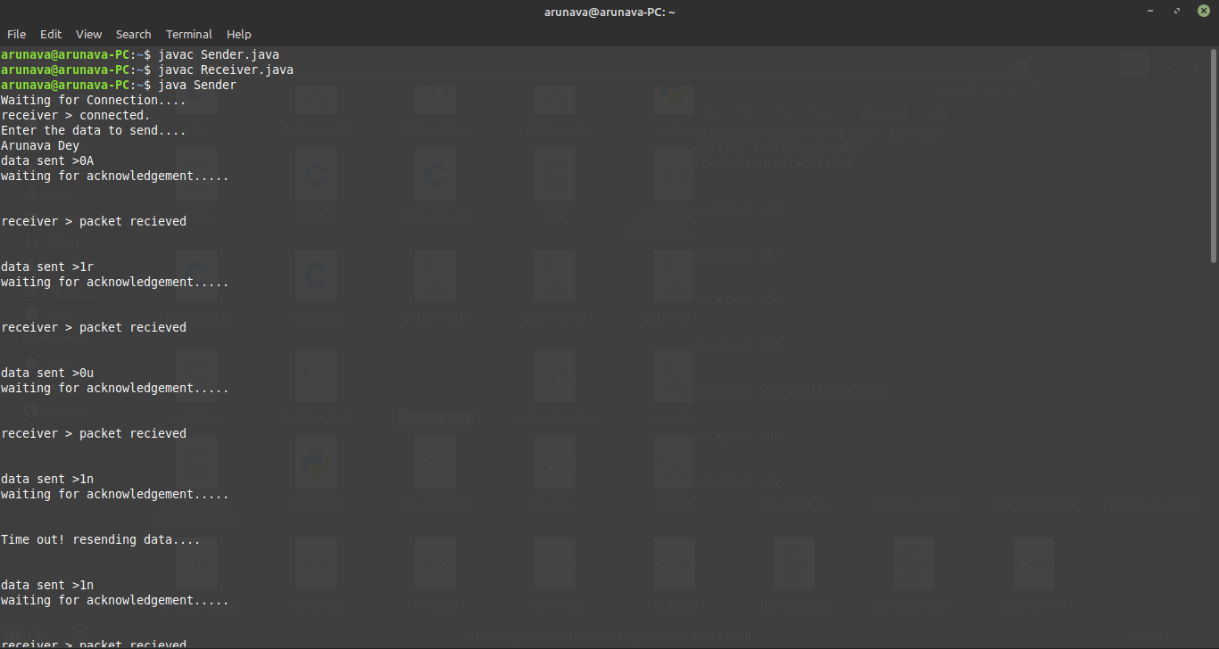
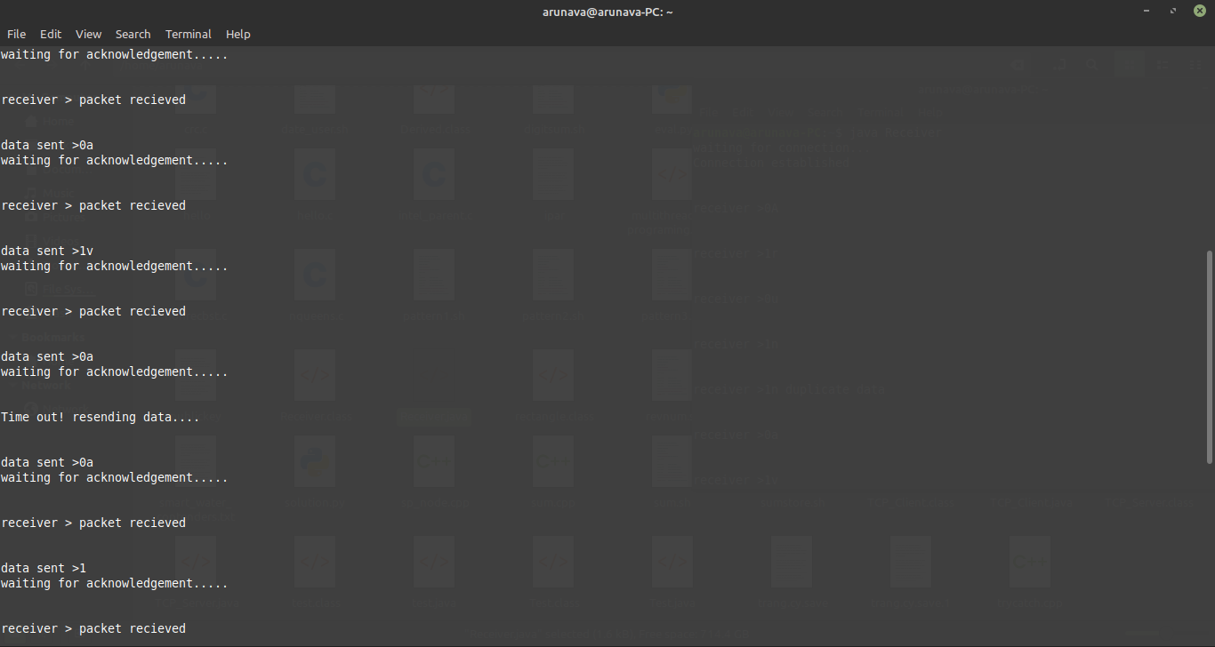
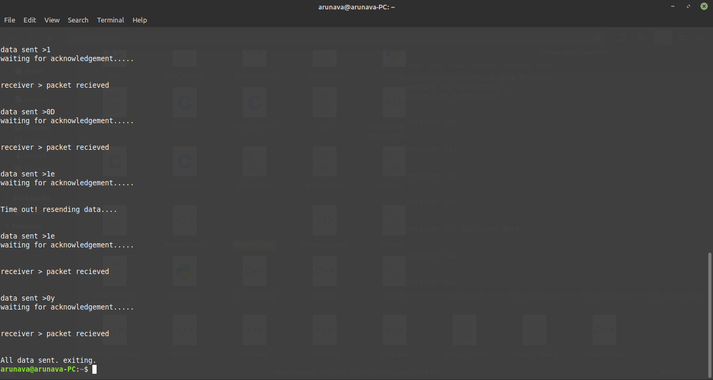

Receiver Interface

